**DATA IMPORTING TOOL**

By

**Panja, Kumara Satya Gopal**

[kpqmd@mail.umkc.edu](mailto:kpqmd@mail.umkc.edu)

**+1(913)636-5588**

**1 Introduction:**

Nowadays we can use many methods for collecting data. For example, company uses google forms, signup forms, csv files etc. Combining the data from various sources is essential. But it is arduous process. It takes so much time. Here I developed a platform to merge the data.

**2 Our System:**

I designed web platform for collecting the data from various csv files. It takes all csv files as input and generates merged data and complicated data as outputs.

**3 Technologies Used:**

HTML, PHP, MySQL, PHP

**4 Functionalities:**

* Takes csv files as input
* Storing the data in database
* Merging the data
* Finding conflicts
* Displaying data

**5 Screenshots:**

**5.1 Our System before submitting csv files:**

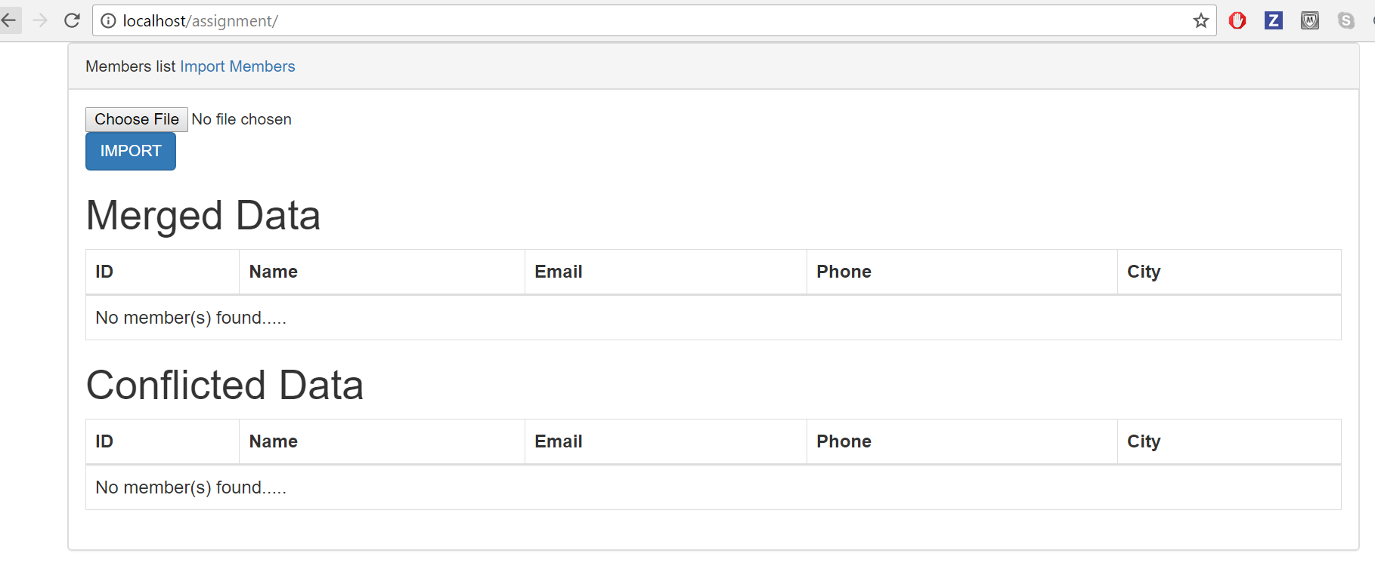

**Fig 1**

**5.2 Input CSV File1:**

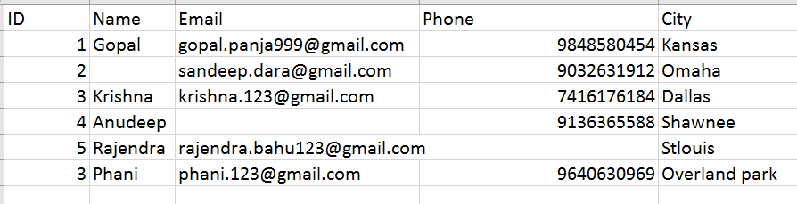

**Fig 2**

**5.3 Application after submitting first csv file:**

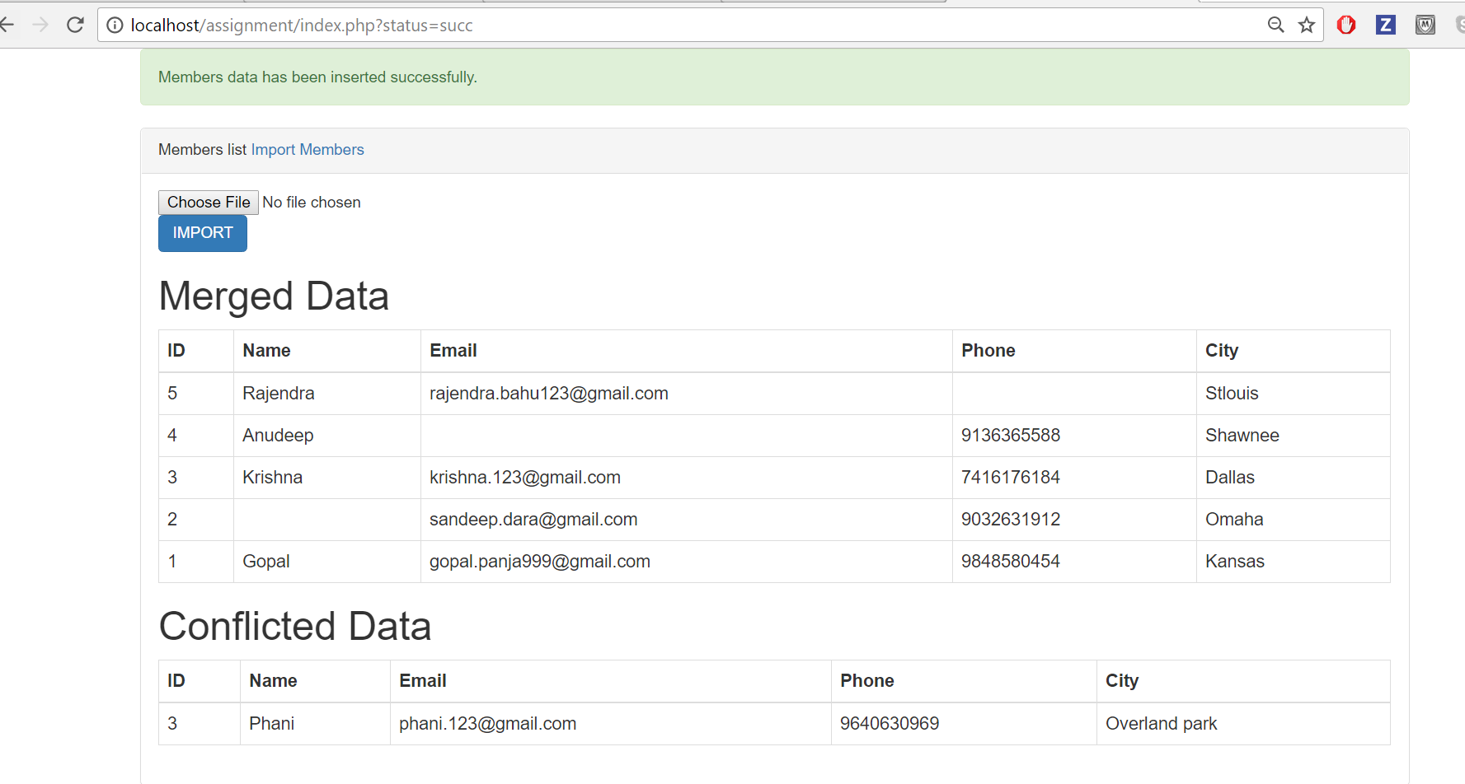 **Fig 3**

**5.4 Input CSV File2:**

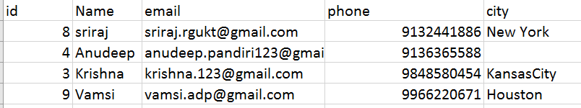

**Fig 4**

**5.5 Application after Submitting Second CSV File:**

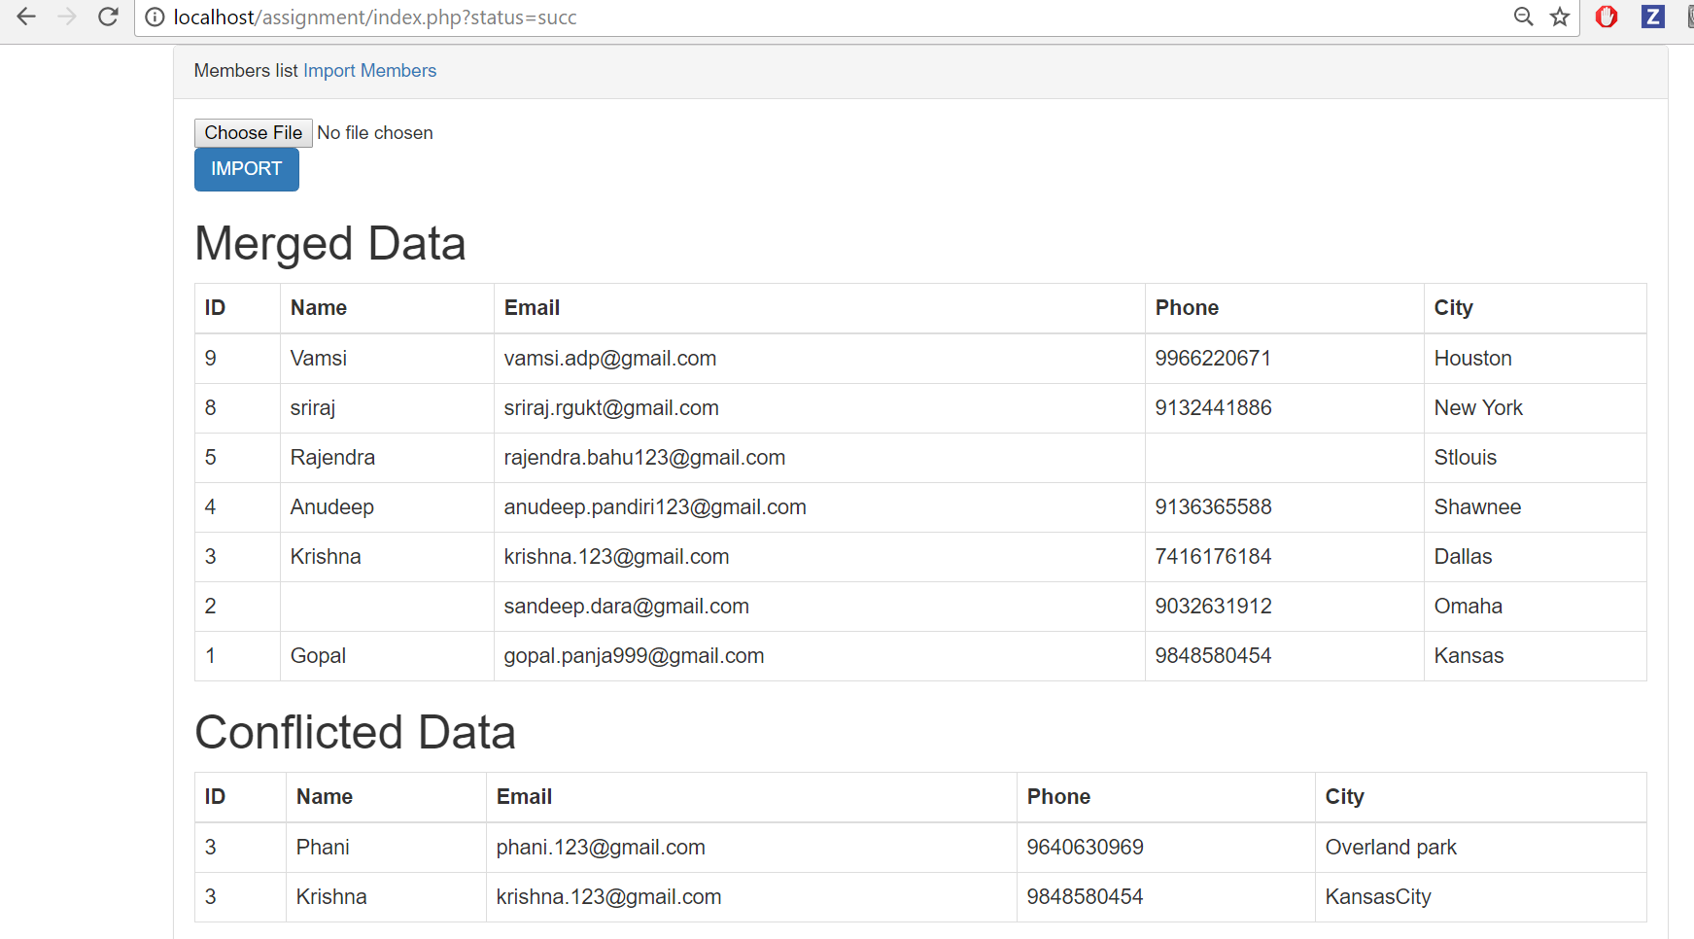

**Fig 5**

**5.6 Input CSV File3:**

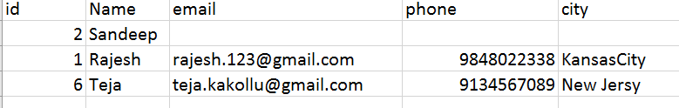

**Fig 6**

**5.7 Application after submitting third input file:**

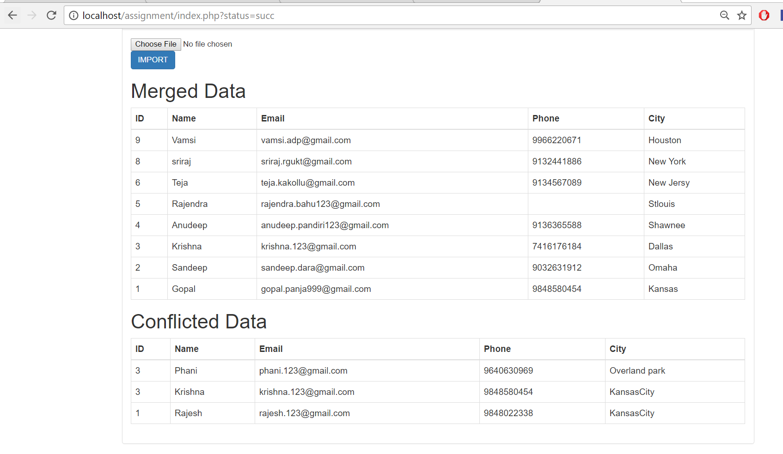

**Fig 7**

**5.8 Merged Data in Database:**

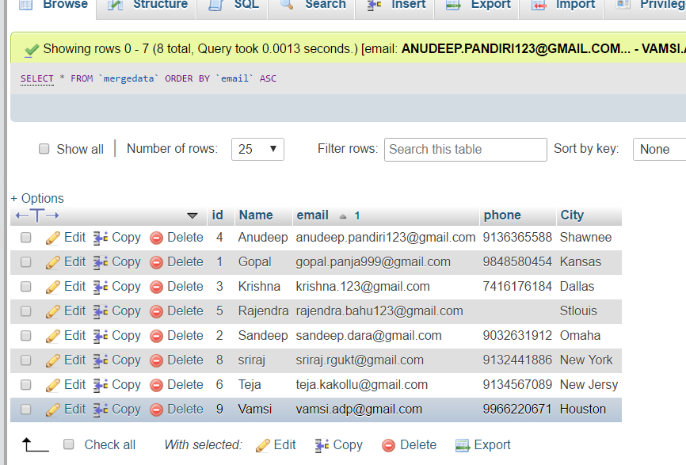

**Fig 8**

**5.9 Conflicted Data in Database:**

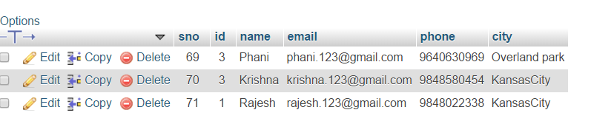

**Fig 9**

**6 Results:**

**6.1 Merged data:**

In first CSV file ID number 4 doesn’t contain any email id. But in second CSV file ID number 4 contains email id. I merged this email id to that row in database. And ID number 2 doesn’t contain any name in first CSV file but it contains value in third file. So, I added that name to the row which contains id number 2.

**6.2 Conflicted Data:**

Already Krishna has id number 3. So, whenever we are trying to add Phani with id number 3, it goes into conflicted data. Krishna has conflict with City name. And Rajesh got conflict with id number.

**7. Project Link:**

Video**:** <https://www.useloom.com/share/932f4168a2f54a3484f57d928badf636>

Project: <https://github.com/Gopal529/Data-Importing-Tool>

**8. References:**

[www.google.com](http://www.google.com)

[www.tutorialspoint.com](http://www.tutorialspoint.com)